**DIGITAL NURTURE 4.0 DEEP SKILLING JAVA FSE-WEEK1**

**NAME: SIVITHA GUNASEKARAN   
SUPERSET ID: 6413354**

**WEEK 1: Algorithms Data Structures  
TASK 2:**

**Financial Forecasting**

**Scenario:**

You are developing a financial forecasting tool that predicts future values based on past data.

**Steps:**

1. **Understand Recursive Algorithms:**
   * Explain the concept of recursion and how it can simplify certain problems.
2. **Setup:**
   * Create a method to calculate the future value using a recursive approach.
3. **Implementation:**
   * Implement a recursive algorithm to predict future values based on past growth rates.
4. **Analysis:**
   * Discuss the time complexity of your recursive algorithm.
   * Explain how to optimize the recursive solution to avoid excessive computation.

**MY CODE FILES:**

**FinanceForecating.java**

package demo;

import java.util.*;

public class FinancialForecasting {

public static double calculateFutureValue(double presentValue, double growthRate, int years) {

if (years == 0) {

return presentValue;

}

return *calculateFutureValue*(presentValue, growthRate, years - 1) * (1 + growthRate);

}

public static void main(String[] args) {

Scanner scanner = new Scanner(System.*in*);

System.*out*.print("Enter initial amount: ");

double initialAmount = scanner.nextDouble();

System.*out*.print("Enter annual growth rate (in %): ");

double annualGrowthRate = scanner.nextDouble() / 100;

System.*out*.print("Enter number of years to forecast: ");

int forecastYears = scanner.nextInt();

double futureValue = *calculateFutureValue*(initialAmount, annualGrowthRate, forecastYears);

System.*out*.printf("Future value after %d years: ₹%.2f%n", forecastYears, futureValue);

}

}

**Output:**

Enter initial amount: 10000

Enter annual growth rate (in %): 8

Enter number of years to forecast: 5

Future value after 5 years: ₹14693.28

**MY SCREENSHOT PROOFS BY RUNNING THE ABOVE SAMPLE CODE:**

**FinanceForecasting.java**

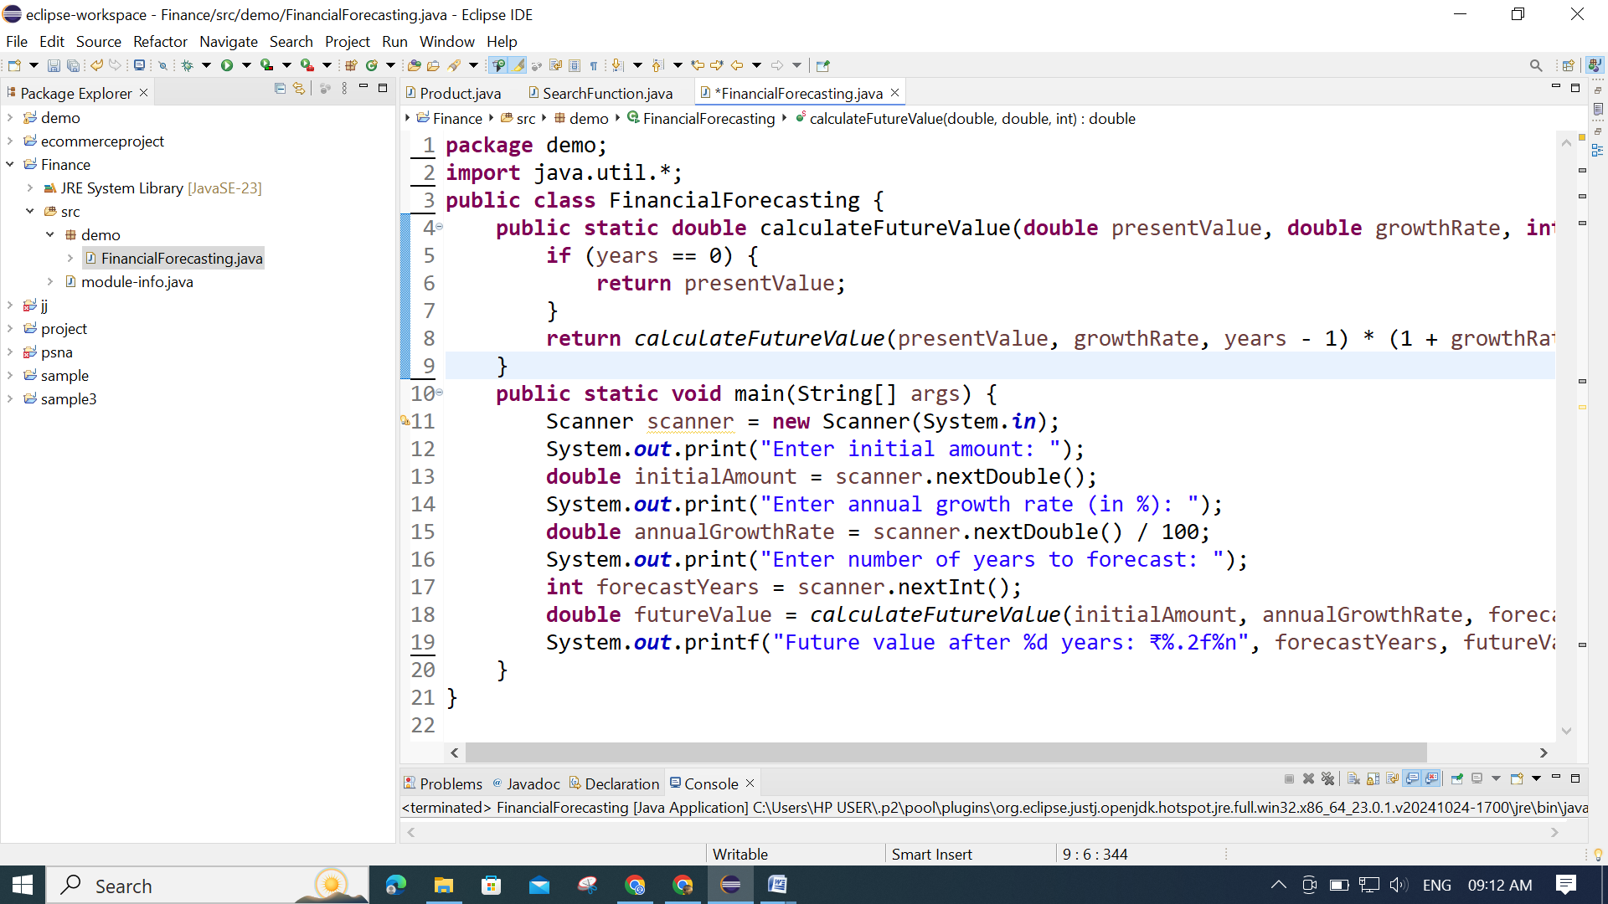

**OUTPUT:**

